**21Q. . Using Raptor - Draw the flowchart to find whether the given number is prime or not.**

**Aim:** To draw the flowchart to find whether the given number is prime or not.

**Software used:** Raptor.

**Diagram:**

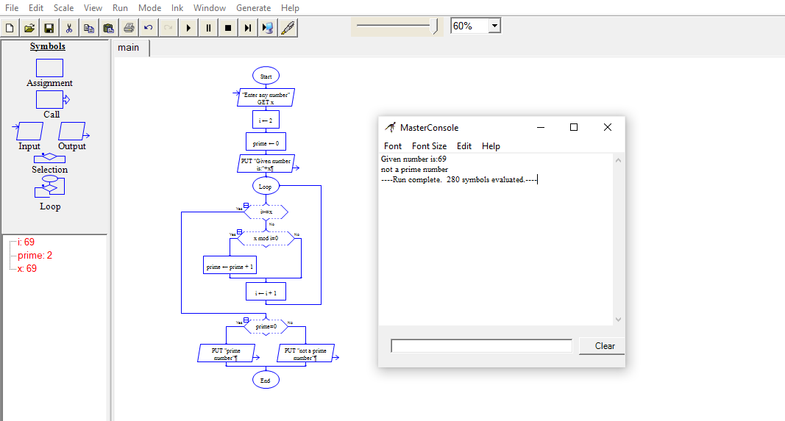

**Result:** Flowchart to find whether the given number is prime or not was completed and output verified.

**22Q.** . Find Cyclomatic Complexity for a graph having number of edges as 13, number of nodes as 17 and number of predicate nodes in the flow graph as 5.

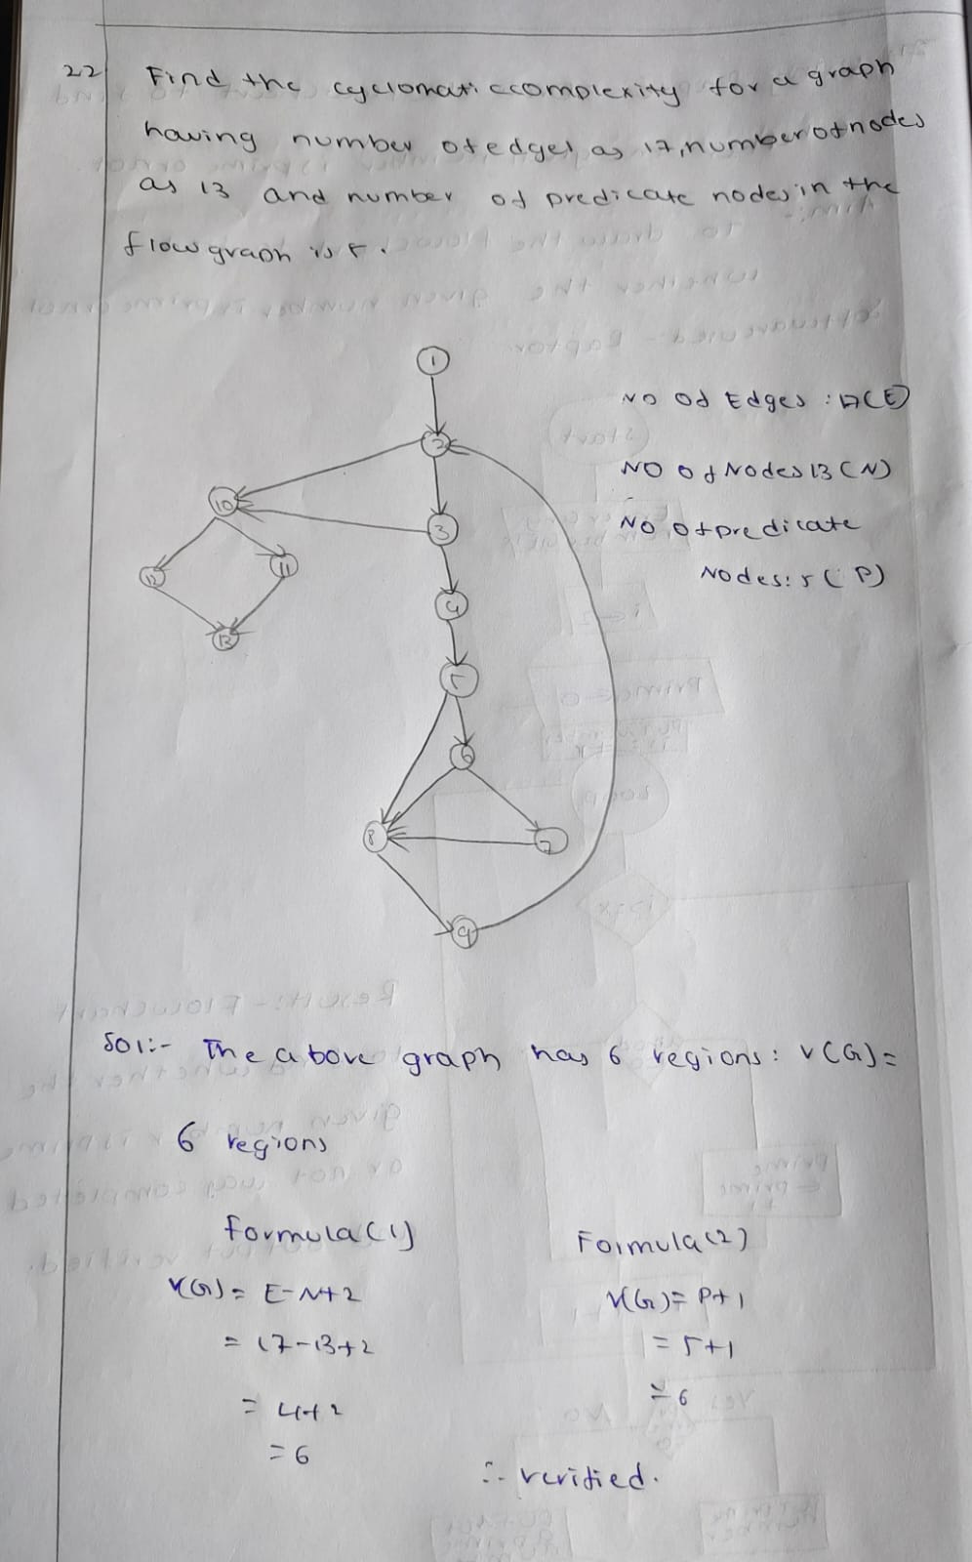

23. Draw an Activity diagram for Online banking System using CASE tools.

***AIM:***

To draw an Activity diagram for Online banking system.

***SOFTWARE USED:***

UMBRELLO:

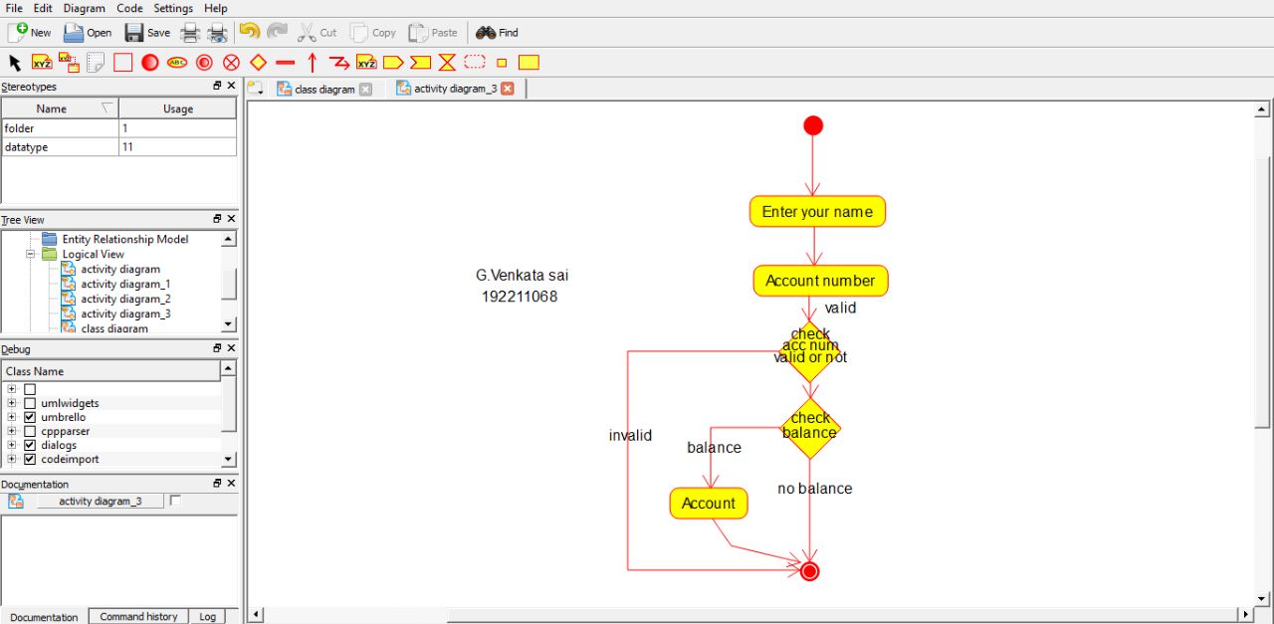

***RESULT:***

Activity diagram for Online banking System was successfully completed.

**24.Draw a Activity diagram for e- Library online public access catalog System using CASE tools.**

**Aim:** To draw a Activity diagram for e Library online public access catalogSystem.

**Software used:** Umbrello.

**Diagram:**

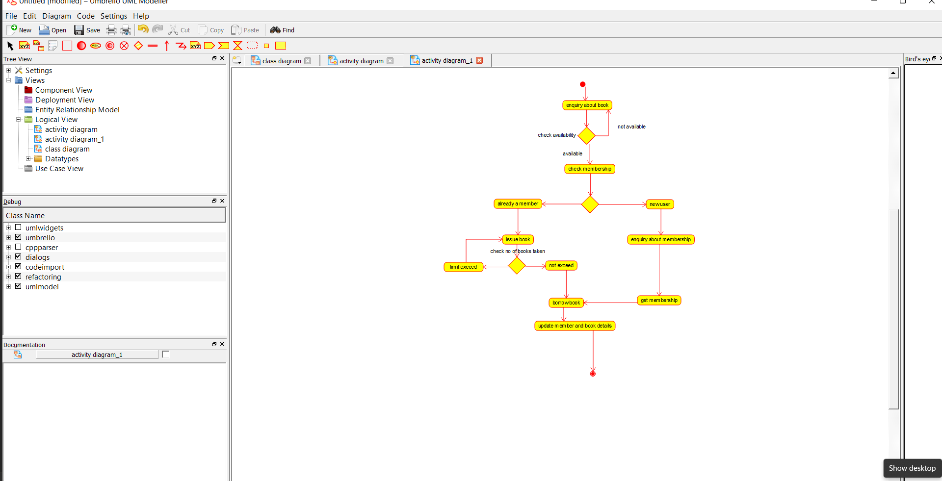

G Venkata sai

**Result:** Activity diagram for e- library system was successfully completed.

**25.Draw a class diagram for e- Library online public access catalog System using CASE tools.**

**Aim:** To draw a class diagram for e Library online public access catalogSystem.

**Software used:** Umbrello.

**Diagram:**

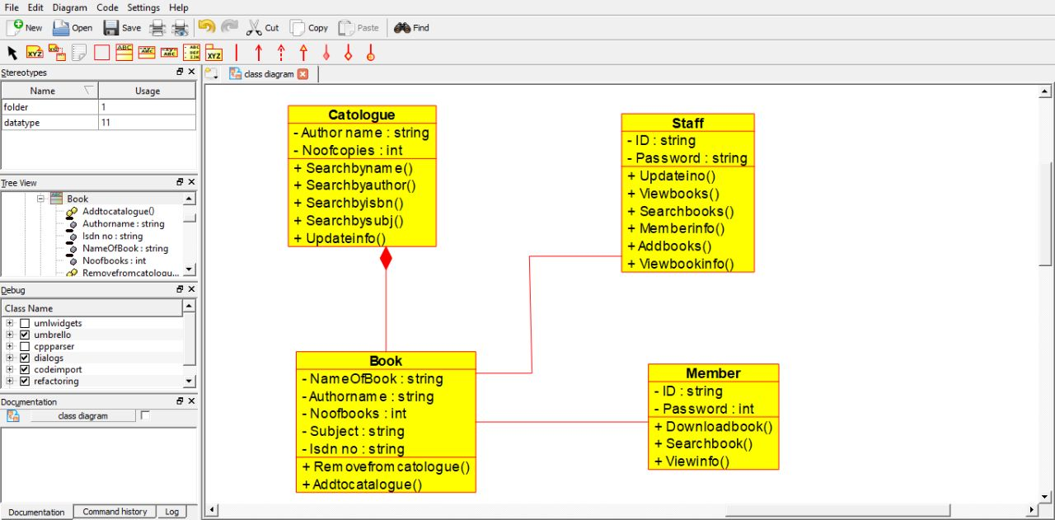

G Venkata sai

**Result:** class diagram for e- library system was successfully completed.

**26Q.Draw a use case diagram for a restaurant system. The activity of the restaurant system is listed below. Receive the customer food orders, serve the customer with their ordered food, collect payment from customers, store customer payment details, order raw materials for food products, pay for raw materials and pay for labour.**

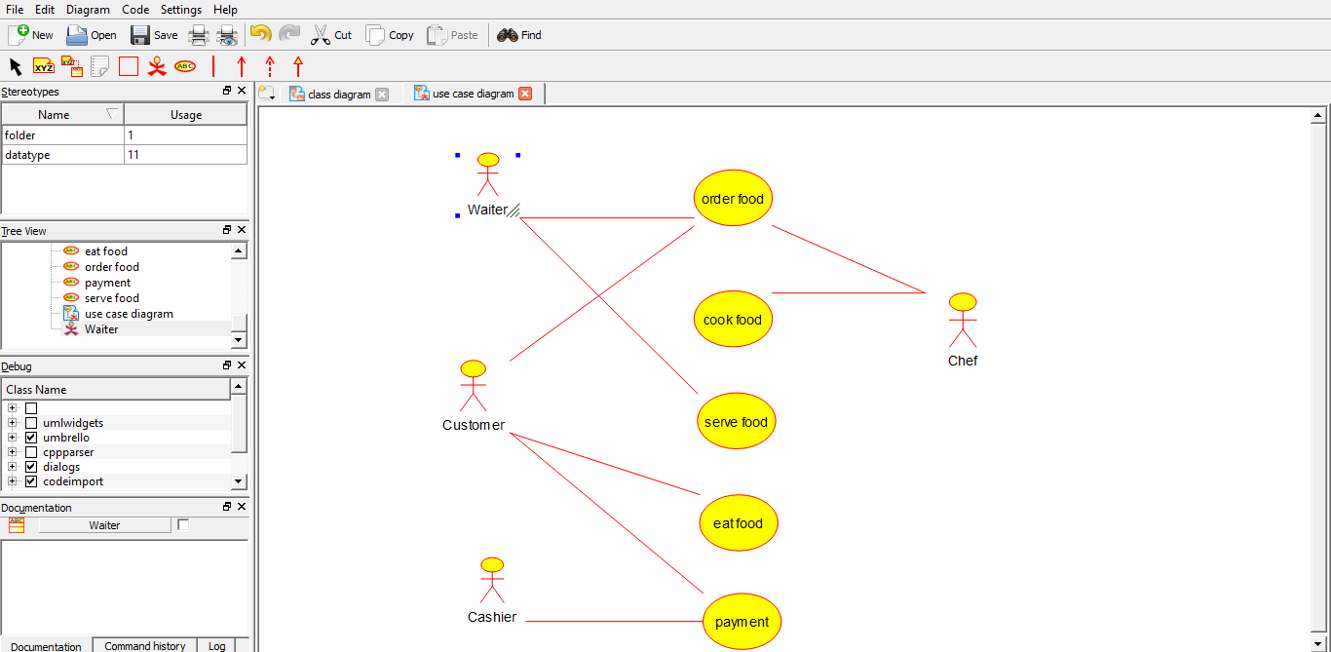

G venkata sai

**27Q. Draw a class diagram for a restaurant system. The restaurant system is listed below. Receive the customer food orders, serve the customer with their ordered food, collect payment from customers, store customer payment details, order raw materials for food products, pay for raw materials and pay for labour.**

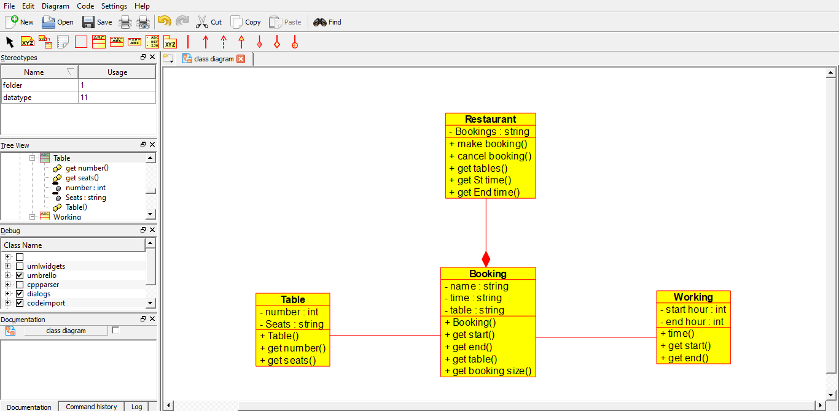

G venkata sai

**28Q.Make a class diagram to model for a quiz system. The user can request a quiz system. A user can request a quiz for the system. The system picks a set of questions from its database, and composes them together to make a quiz. It rates the user’s answers and gives hits if the user requests it. In addition to users, we also have helpers who provide questions and hints. And administrators who must certify questions to make sure they are not too big, and that they are correct.**

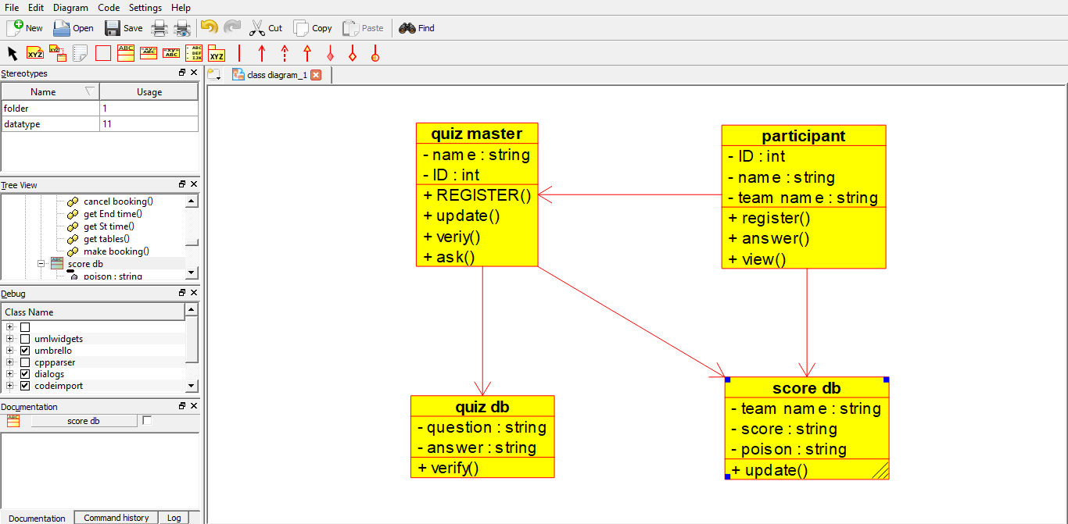

G venkata sai 192211068

**29Q.Draw a use case diagram to model for a quiz system. A user can request a quiz system. A user can request a quiz for the system. The system picks a set of questions from its database, and composes them together to make a quiz. It rates the user’s answers and gives hits if the user requests it. In addition to users, we also have helpers who provide questions and hints. And administrators who must certify questions to make sure they are not too trival, and that they are correct.**

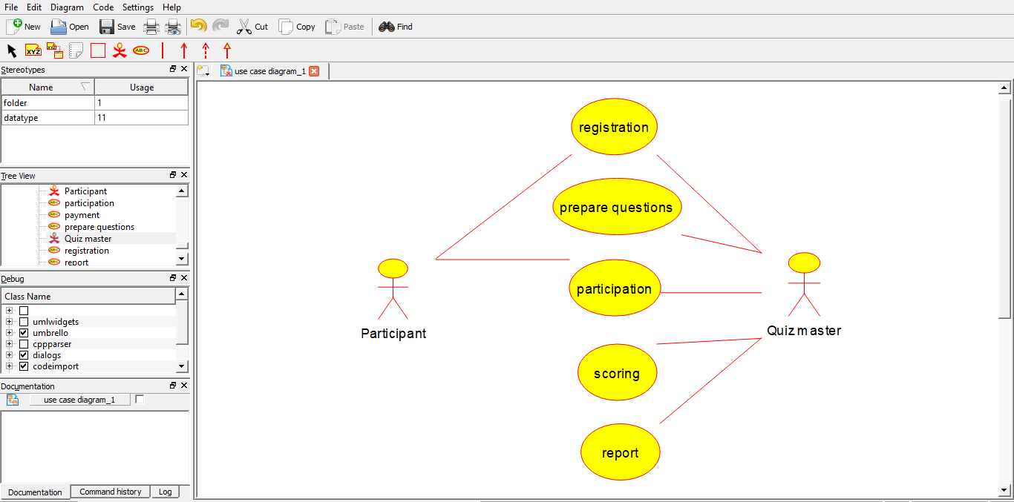

G venkata sai 192211068

**30Q.Using Raptor-Draw and validate the flow chart to calculate factorial of a number.**

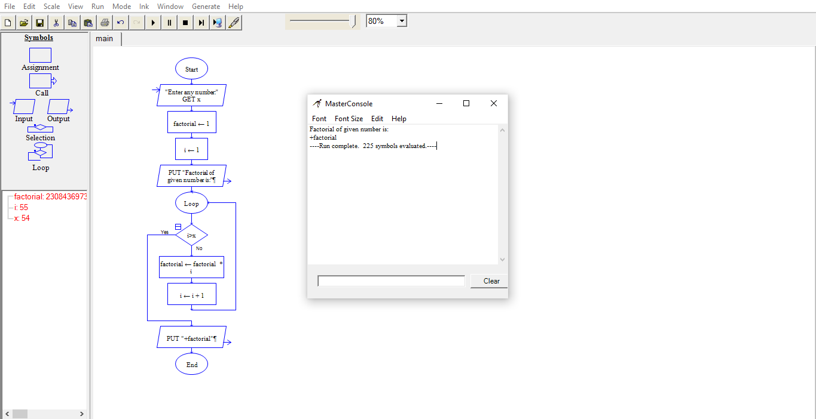

G venkata sai 192211068

**31. Using Raptor – Draw and validate the flowchart to find odd series of the given number.**

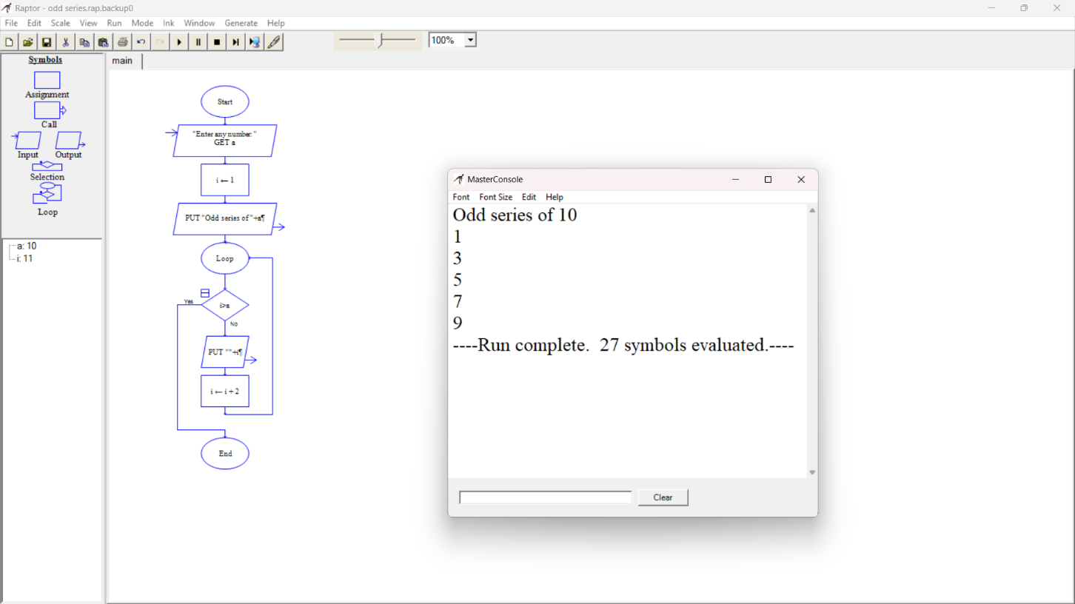

G venkata sai 192211068

**Using Raptor – Draw and validate the flowchart to find even series of the given number.**

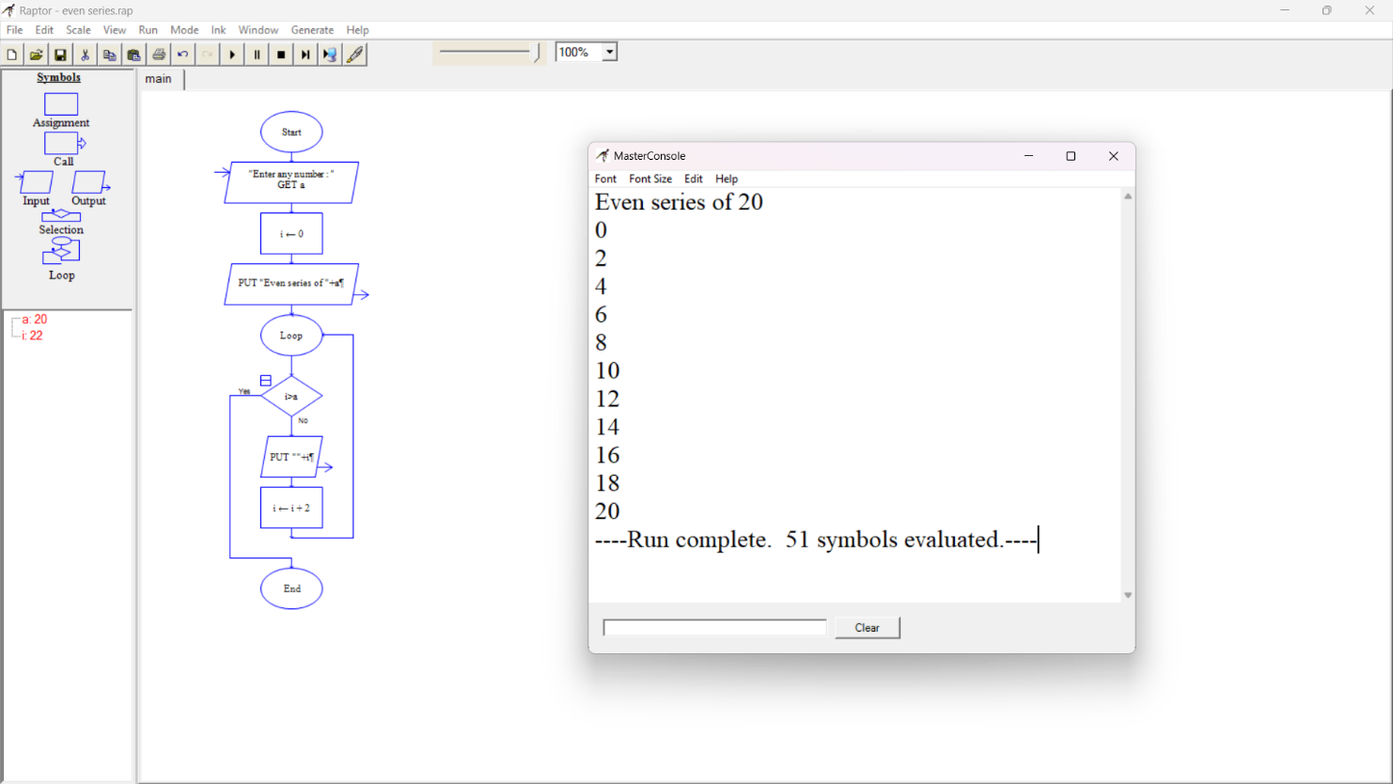

**32Q. .Using Raptor-Draw and validate the flow chart to display the reverse of the string.**

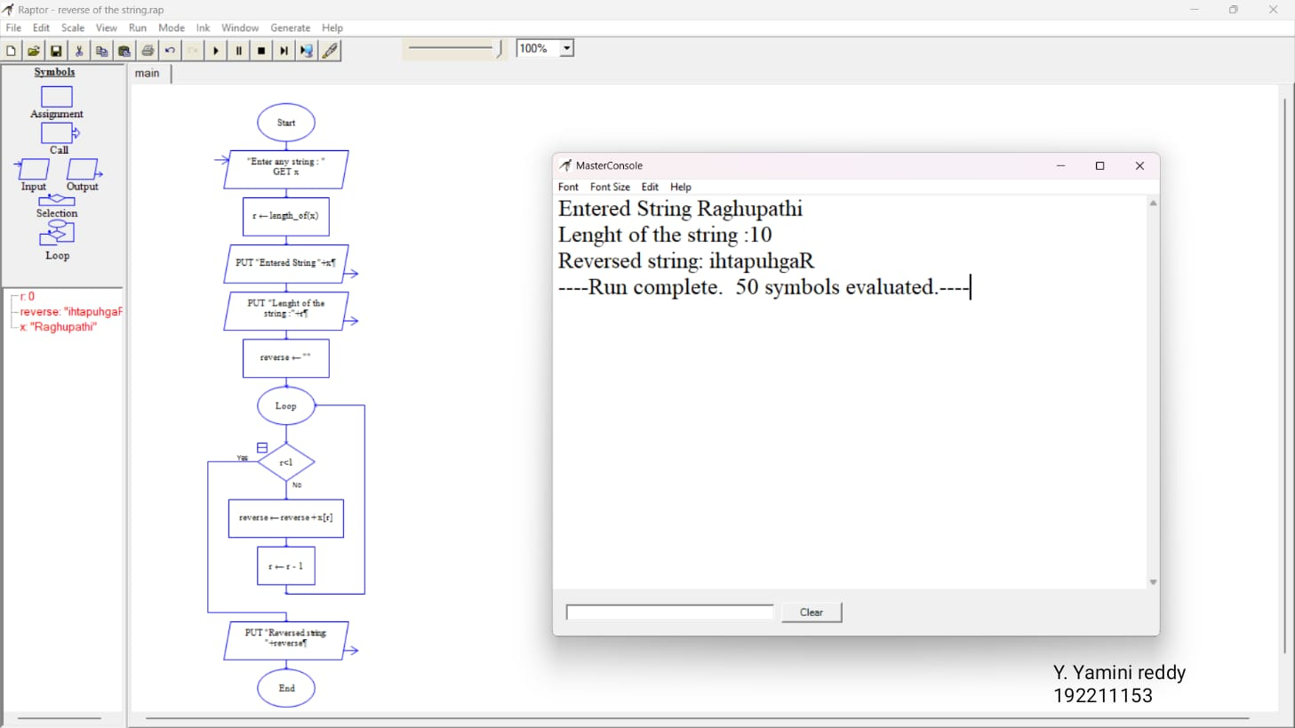

**33Q. Using Raptor-Draw and validate the flow chart to find largest of n Numbers.**

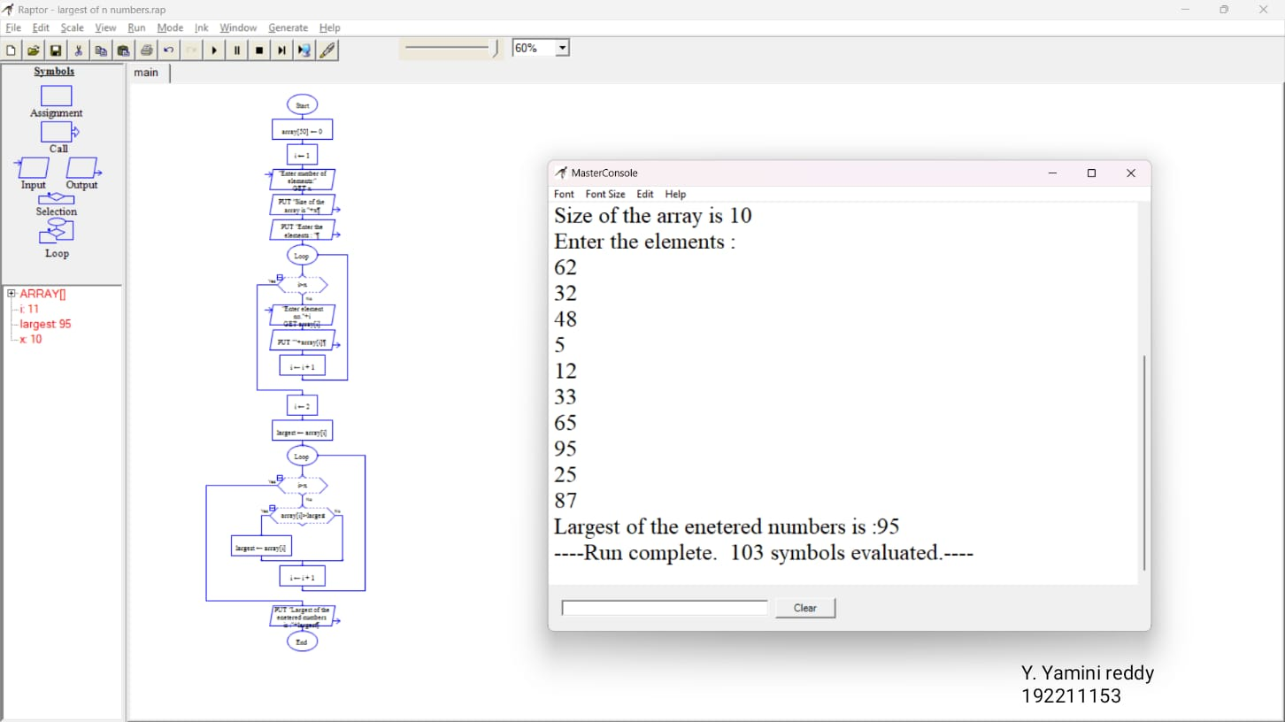

**34Q.Find cyclomatic complexity for a graph having number of edges as 20,number of nodes as 15 and number of predicate nodes in the flow graph as 4.**

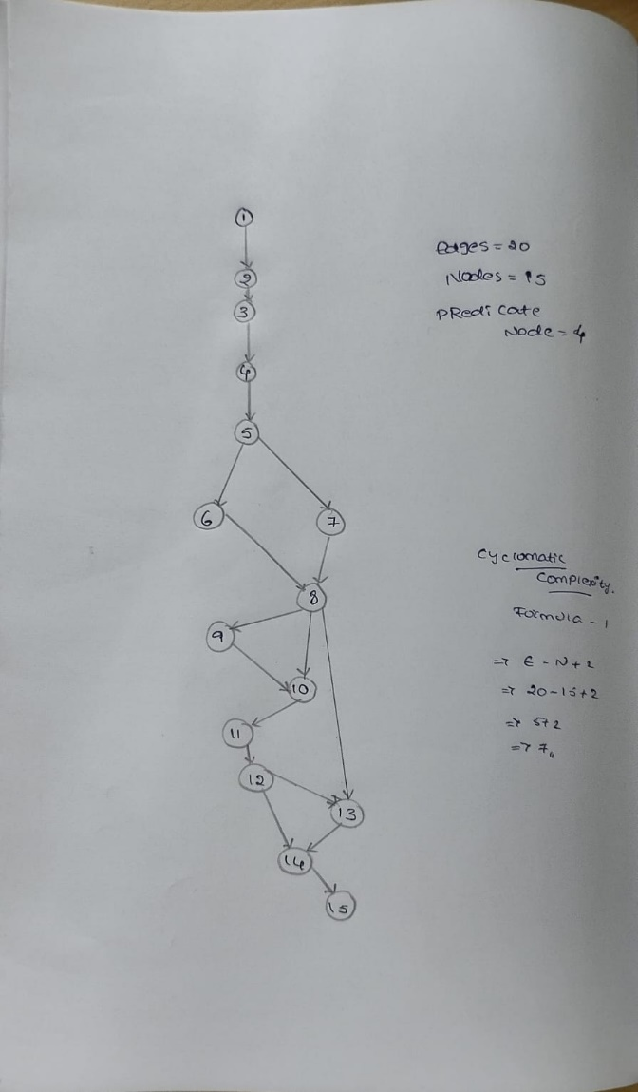

**35Q. Using Raptor- Draw and validate the flowchart to calculate Fibonacci series.**

**Aim:** To draw and validate the flowchart to calculate Fibonacci series.

**Software used:** Raptor.

**Diagram:**

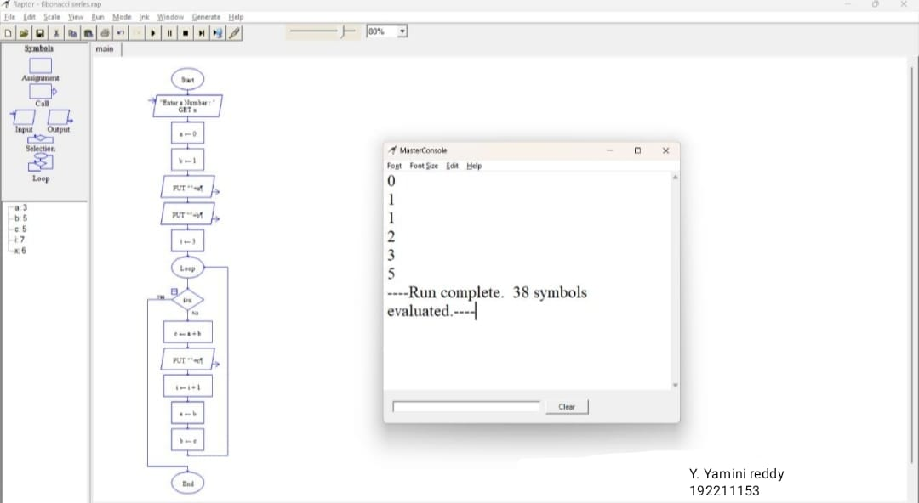

**Result:** Flowchart to calculate Fibonacci series was completed and output verified

**36Q.using Raptor-Draw the flowchart to find smallest of n Numbers.**

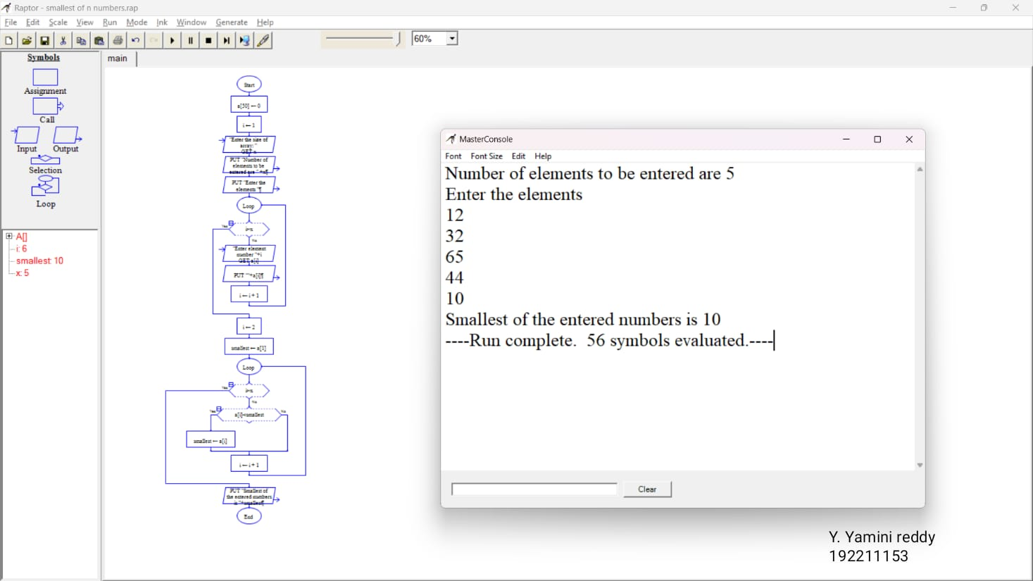

**37Q.Draw use case diagram for E-wallet online prepaid account.**

**Aim:**To draw a use case diagram for E-wallet online prepaid account

**Software used:**umbrello

**Diagram:**

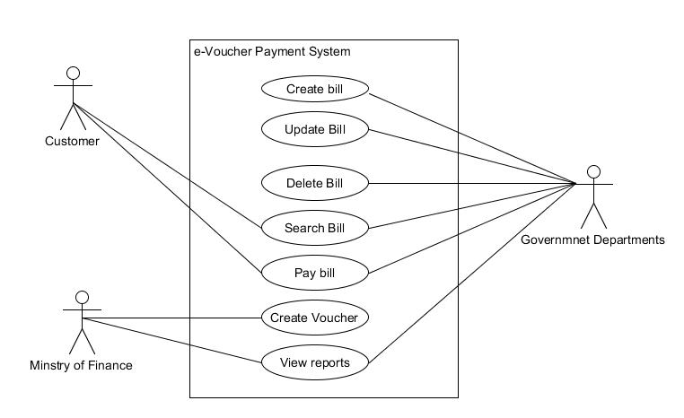

G venkata sai 192211068

**Result:** use case diagram for E-wallet online prepaid account was completed successfully.

**38Q. Draw a class diagram for online security management system**

**Aim:**To draw a class diagram for online security management system

**Software used:**umbrello

**Diagram:**

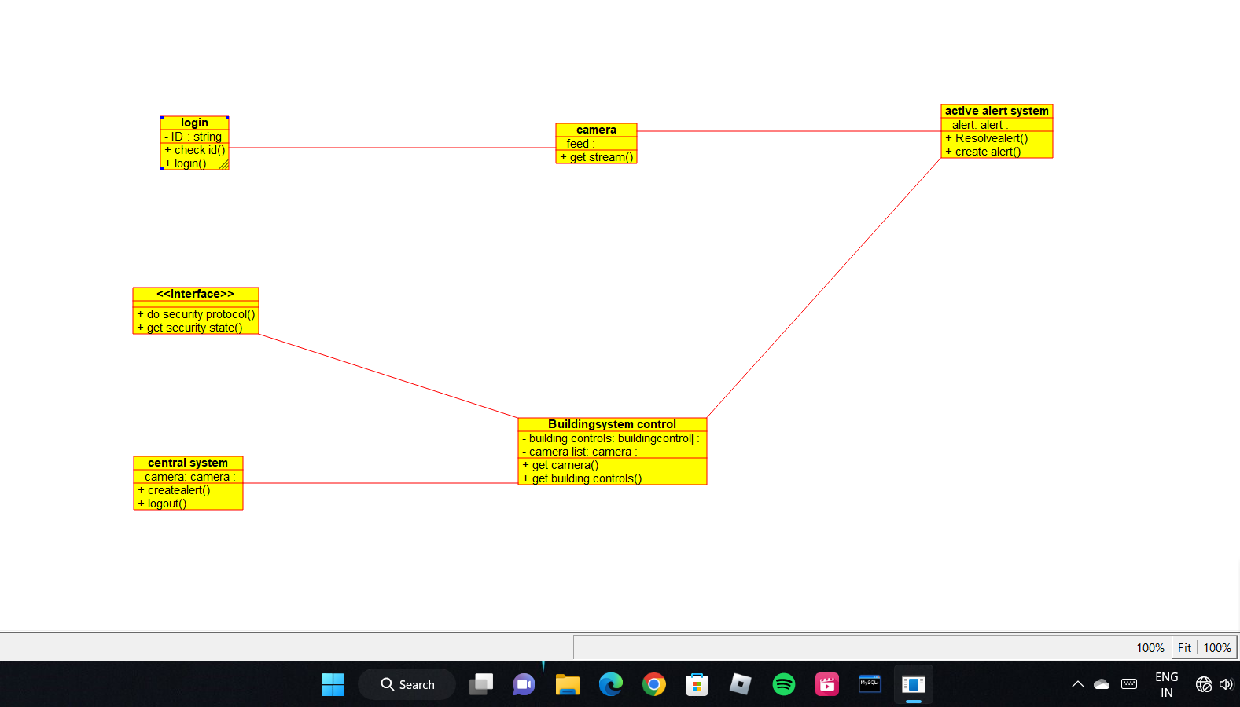

G venkata sai 192211068

**Result:** Class diagram for online security management system was successfully completed

**39Q. . Draw a Class diagram for Online Voting System using CASE tools**

**Aim:** To draw a class diagram for online voting system.

**Software Used:** Umbrello.

**Diagram:**

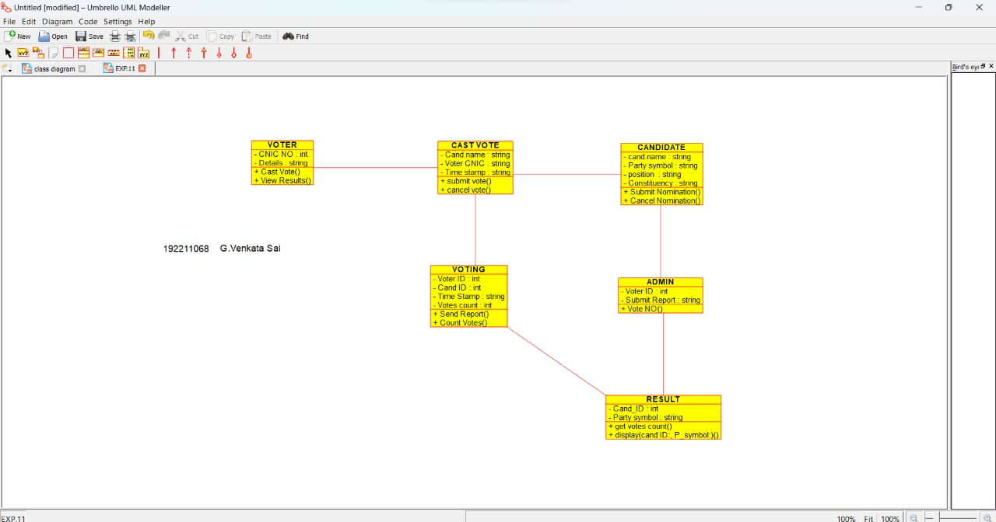

**Result:** Class diagram for online voting system was successfully completed.

**40Q. Using Raptor- Draw the flowchart to check whether the given number is a palindrome or not.**

**Aim:** To draw the flowchart to check whether the given number is a palindrome or not.

**Software used:** Raptor.

**Diagram:**

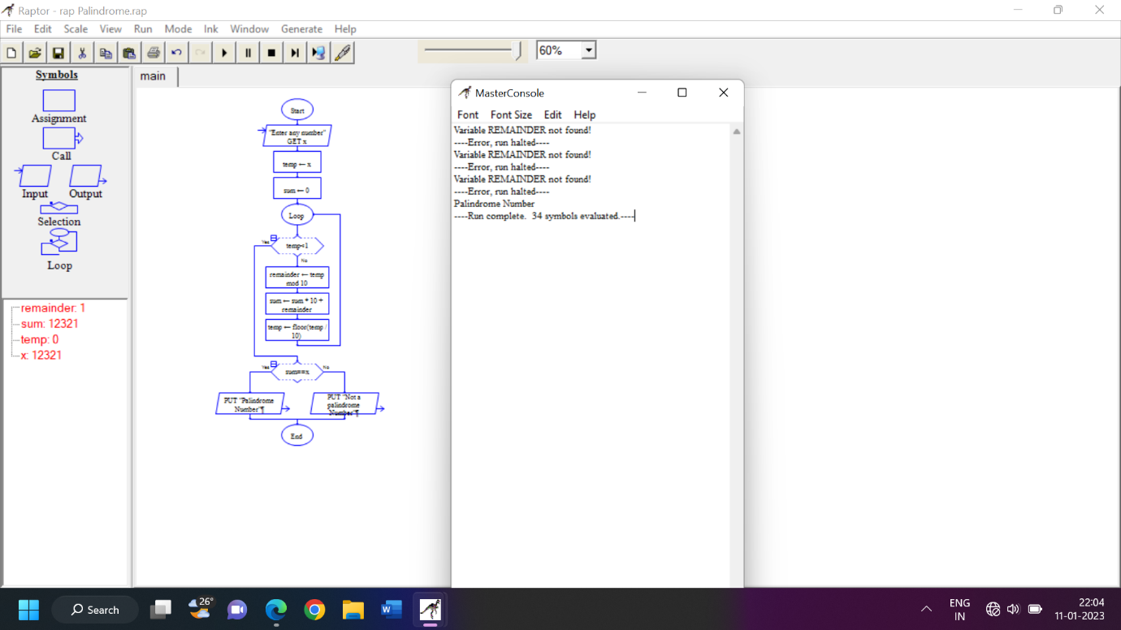

G venkata sai 192211068

**Result:** Flowchart to check whether the given number is palindrome or not was completed and output verified.